

By

TeaM8s: Jake Scheide, Bailey Sostek, Kyle Savell and Mike Macninnes

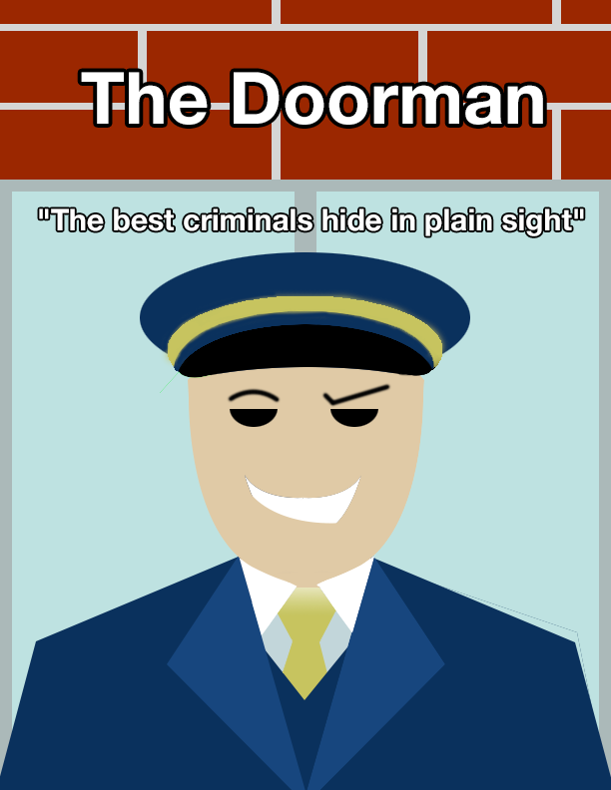

**Back Box Description:**

Enter Jim; an unskilled citizen living off whatever money he can make from odd jobs and busking. Naturally, when he receives a phone call from Le Grand Mone, the fanciest hotel in the area, he jumps at the chance to be The Doorman. The intriguing conversations with guests will make him question just how expensive a room is – and the worth of the items they bring with them. Can you be a mini Robin Hood and steal your fortune from the eccentric guests? Perhaps, with a little charm, suave and patience… After all, the best criminals hide in plain sight!

**Features:**

* Visual novel game coded in Ren’Py
* Incredibly deep conversation branches
* Unique objectives generated for each playthrough
* Variable difficulty levels give players opportunities to both learn and master the game
* Original art and dialogue for seven unique characters and items

A brief (200-300 word) description that specifically relates your delivered prototype back to your [concept document](http://users.wpi.edu/%7Ebmoriarty/imgd1001/a05.html). Discuss how the experience goals are, in fact, delivered by the prototype, or how they are not (and why not). If there were significant deviations from the original concept, these should be called out, with brief reasons provided.

**Questions from Playtest Survey:**

|  |  |  |  |  |
| --- | --- | --- | --- | --- |
| |  |  |  | | --- | --- | --- | | 1. | Did you find the item? |  | |  |
| |  |  |  | | --- | --- | --- | | 2. | If you answered 'YES', how difficult did you find the game? |  | |  |
| |  |  |  | | --- | --- | --- | | 3. | If you answered 'NO', how difficult did you find the game? |  | |  |
| |  |  |  | | --- | --- | --- | | 4. | Did you use the notepad? |  | |  |
| |  |  |  | | --- | --- | --- | | 5. | Did the game feel original? |  | |  |
| |  |  |  | | --- | --- | --- | | 6. | Did you notice any bugs or any technical glitches? (Purely errors in gameplay, rather than story/spelling) |  | |  |
| |  |  | | --- | --- | | 7. | General Comments / Suggestions | |  |

**Non-original Asset List & Documentation:**

|  |  |  |  |  |
| --- | --- | --- | --- | --- |
| Type | Filename | Use in game | Time | Source & Information |
| music | Music_Menu.mp3 | Background music for menu | 3:10 | "How it Begins" Kevin MacLeod (incompetech.com) |
| music | Music_Intro.mp3 | Background music for intro sequence | 5:44 | "Sunflower Dance Party" Kevin MacLeod (incompetech.com) |
| music | Music_Lobby.mp3 | Background music for lobby | 2:57 | "Deliberate Thought" Kevin MacLeod (incompetech.com) |
| music | Music_Night.mp3 | Background music for night-time | 3:12 | "Satiate - only strings" Kevin MacLeod (incompetech.com) |
| sound | Sound_Elevator.wav | Elevator beeping sound to signal floor select. | 6.6 sec | http://www.freesound.org/people/GilPS/sounds/241763/ |
| sound | Sound_Lose.wav | Music/sound for lose state | 3.69 sec | https://freesound.org/people/LittleRobotSoundFactory/sounds/270329/ |
| sound | Sound_Win.mp3 | Music/sound for win state | 2.06 sec | https://freesound.org/people/kiddpark/sounds/201159/ |
| sound | Sound_Click.wav | Sound for pressing a menu/dialogue button | .045 sec | http://www.freesound.org/people/kwahmah_02/sounds/256116/ |
| sound | Sound_Door.wav | Sound for a character leaving a scene (door sound) | .65 sec | http://www.freesound.org/people/THE_bizniss/sounds/53269/ |
| sound | Sound_Phone.wav | Phone ringing | 20.1 sec | http://www.freesound.org/people/cbakos/sounds/50646/ |
| sound | snore.mp3 | Snore sound for | 3.0 sec | Hollywood sound effects library |

**Original Concept for Lobby Scene:**

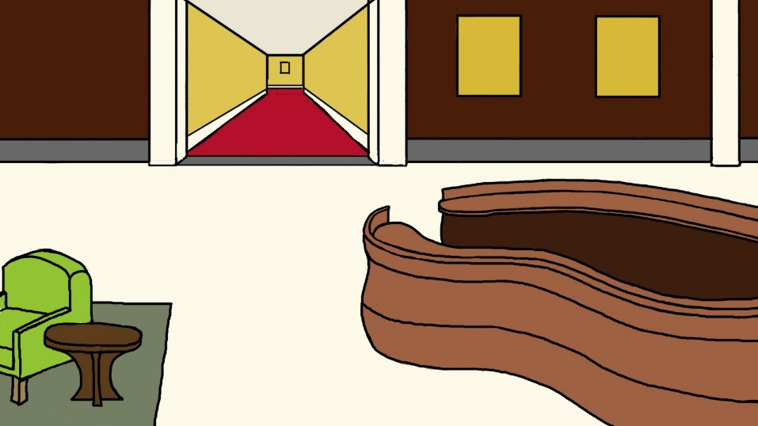

**Final version:**

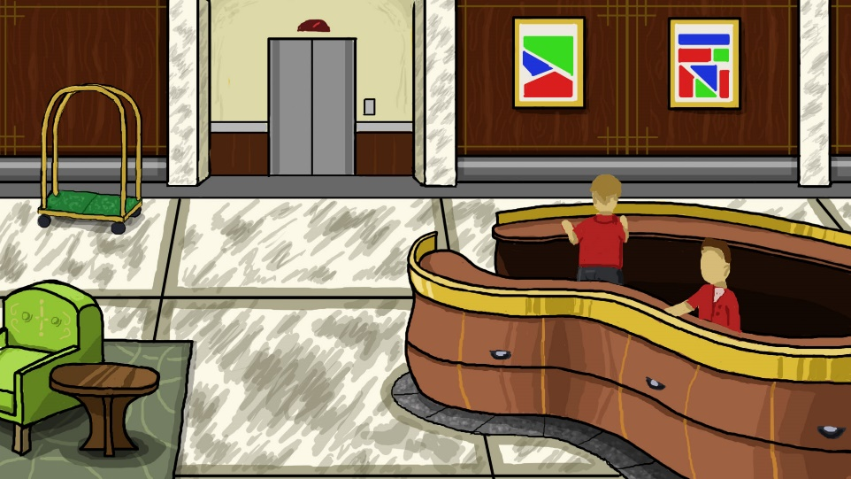

**Character Art:**

